PROJECT

Supervisor: | PHAN THANH VINH
Curriculum: | ACCP i7.1
Semester: | 3
Batch Code:
Group: | Institute of Fine Arts
Students: | - LE DANG SON  - DOAN MINH PHONG  - LI THIEN KIM  - QUACH LIEN PHONG

Table of contents
- Acknowledgements
- Introductions
- Problem Definition.
- Customer Requirement Specification.
- Functional Requirement Specification.
- Use Case and Diagram.
- Functional of site.
- Interface Design Document.
- Database Design.

- Acknowledgements

- Introductions
Our client is an institute by the name “Institute of Fine Arts”, which has been started by the two well-trained professionals who are one of the standard people in the field of animation and fine arts. The procedures that they follow are they first conduct classes on paintings, animation, etc.
During the course schedules, they conduct competitions among the students, for which all the students must participate in these competitions and have to submit their paintings with in the stipulated time. They ask the students to come up with some paintings, which they need to create with their own creativity along with some sentences like poems, quotations, stories, etc. that are to be described along with their paintings. The students based on their creativity, design on their respective computers and then submit their designs (paintings) in the form of a jpeg file, with in the stipulated time to the college.
Once the due date is crossed, the submissions of the designs as created by the students will not be accepted. These students will be disqualified in the competitions. And after the due date the college will not evaluate the designs received from the students based on the creativity and the quotations or poems, and then they will select the best designs and distribute the awards to the students with the best designs.
They at times in order to boost up the competitive spirit in the students, they will display the best paintings done by the students in the exhibitions, at which the paintings will be sold at the price decided by the painter (Student). The money received for the painting which is sold out in the exhibition is handed over to the student itself.
- Problem Definition
They usually maintain the competition details through pen and paper. Because of which they are facing the problems in retrieving and fetching the records, for which it consumes too much of time, as when a student wants to change the painting submitted, etc. the staff should first search the records and then update the details accordingly.
Now, the management had come up with a new idea where in they can have a website of their own. In this website they want to implement these competitions, where in they can announce the competitions, provide a facility for the students to upload and download the image files. Also the student can update or remove the pictures of the same. Thus through this website they can automate the process, and as well reduce the time consumption in evaluating and fetching the records of the students, designs, etc. So they had approached you to help them by building a website by building the following functionalities, in it.

- Customer Requirement Specification.
The website which you build must have the following functionalities.
- The website should have the following modules
  - Manager
  - Administrator
  - Staff (teacher)
  - Student
- On the home page, the details of the upcoming competitions, ongoing competitions, the list of the students who are awarded for the previous competition, the total submissions done for the ongoing competition, etc.
- Through the administrator module, one can perform the following functionalities
    - Maintain (insert, update, delete and search and retrieve) the details of the staff along with the login details, personal details, work details (like when joined this institution, handles which class, handles which subject, etc.), remarks.
    - Maintain (insert, update, delete and search and retrieve) the details of the students along with the login details, personal, admission details.
- Through the staff login one should be able to perform the following.
    - View the details of the students (personal, and admission details)
    - Maintain (insert, update, delete and search and retrieve) the details of the competitions along with the start date, end date, conditions, award details (like what are the awards that are to be issued for that competition), etc.
    - Maintain (insert, update, delete and search and retrieve) the details of the student’s academic records like they can view the postings done (like the designs as posted by the students, details of the quotations, stories, poems, etc. submitted along with the designs, the date on which it is posted, for which competition is posted), and then they can mark it as either best, or better, or good, or moderate, or normal (based on the creativity and the quotations or poems submitted), or as disqualified (if the date submitted is beyond the end date for the competition) and describe the remarks, like the positive points about the design, negative points about the design, and that of the areas of improvement.
    - Maintain (insert, update, delete and search and retrieve) the details of the awards issued, like which student is awarded and for which competition did the student is awarded, remarks of the competition.
    - Maintain (insert, update, delete and search and retrieve) the details of the upcoming exhibitions that are to be conducted with in the country, so that the students can view the details of the upcoming exhibitions and forward their (students) paintings to the exhibition.
    - Maintain (search and retrieve) the details of the students designs submitted based on the mark assigned (like best, better, good, moderate, normal and disqualified), so that they (staff) can forward the best paintings to the exhibitions for the price that the student has quoted.
    - Maintain (insert, update, delete and search and retrieve) the list of the designs that are sent to the exhibition, along with the price, and the status (like whether the painting is sold out or not, if sold out, what is the price at which it is sold out, whether the money paid for the painting at the time of sale is returned or paid to the student or not), the details of the customer who purchased the painting if the painting is sold, etc.
- Through the student login one should be able to perform the following.
    - The student should be able to view the upcoming competition details along with the awards, details, conditions, etc.
    - The student must be able to upload the designs or the paintings created along with the quotations, stories, etc.
    - The student must be able to change the design or the painting, or the quotations or the story or the description for the painting (why did the student created or designed this painting, why should this painting be the best, etc.) or the poem, etc. once is it is uploaded on the site, provided the end date for the competition in which he/she has submitted this design is not exceeded.
    - Should be able to view the awards given based on the on the competition conducted.
    - Should be able to view all the postings that are marked as best, along with the comments from the staff (areas of improvement, etc.)
    - Should be able to view all the postings that are sent for the exhibitions along with the status (like price of the painting, whether the painting is sold or not, whether the student is paid or not, how much is paid by the customer for that painting sold, etc.)
    - Should be able to view the marks (best, better, etc.) and remarks (like areas of improvement, positive points, etc.) as posted or provided by the staff, for all the paintings that are posted along with the poems, quotations, etc. based on the competitions conducted and he/she had participated till now.
- Through the Manager login one should be able to maintain the following.
    - Should be able to view the details of the students and staff details
    - Should be able to view the competition details that are held till now.
    - Should be able to view the details of the awards issued.
    - Should be able to view all the postings done by all the students till now based on the competitions that are conducted till now.
    - Should be able to view the marks or remarks as provided by the staff for a particular painting.
    - Should be able to view the list of the paintings that are exhibited by the staff, along with the details.
    - Should be able to maintain the details of the upcoming exhibitions in the country.

- Functional Requirement Specification.
Function Name | Descriptions | Conditions
Login | Any member who wants access to the site will need to login. | Must provide your username and password.
Show upcoming competitions | In home page, show upcoming competitions. | Start date of competition after the current date.
Show ongoing competitions | In home page, show ongoing competitions. The total submissions done for the ongoing competition. | End date of competition after the current date and the start date of competition before the current date.
Show list students | In home page, show list students who are awarded for the previous competition. | The winner in previous competition.
Show all exhibitions | In exhibitions page, show list exhibitions and exhibitions detail | Must login
Show all designs of each exhibition | In exhibitions detail page, show list designs of this exhibition. | Must login
Insert, update, delete, search and retrieve the staff | Maintain (insert, update, delete and search and retrieve) the details of the staff along with the login details, personal details, work details (like when joined this institution, handles which class, handles which subject, etc.), remarks. | Addministrator login
Insert, update, delete, search and retrieve the students | Maintain (insert, update, delete and search and retrieve) the details of the students along with the login details, personal, admission details. | Addministrator login
View detail of the student | View the details of the students (personal, and admission details). | Staff login
Insert, update, delete, search and retrieve the competitions | Maintain (insert, update, delete and search and retrieve) the details of the competitions along with the start date, end date, conditions, award details (like what are the awards that are to be issued for that competition), etc. | Staff login
Insert, update, delete, search and retrieve the details of the student’s academic records | Maintain (insert, update, delete and search and retrieve) the details of the student’s academic records like they can view the postings done (like the designs as posted by the students, details of the quotations, stories, poems, etc. submitted along with the designs, the date on which it is posted, for which competition is posted), and then they can mark it as either best, or better, or good, or moderate, or normal (based on the creativity and the quotations or poems submitted), or as disqualified (if the date submitted is beyond the end date for the competition) and describe the remarks, like the positive points about the design, negative points about the design, and that of the areas of improvement. | Staff login
Insert, update, delete, search and retrieve the awards issued | Maintain (insert, update, delete and search and retrieve) the details of the awards issued, like which student is awarded and for which competition did the student is awarded, remarks of the competition. | Staff login
Insert, update, delete, search and retrieve the upcoming exhibitions | Maintain (insert, update, delete and search and retrieve) the details of the upcoming exhibitions that are to be conducted with in the country, so that the students can view the details of the upcoming exhibitions and forward their (students) paintings to the exhibition. | Staff login
Search, retrieve, mark the students designs and forward the best paintings to the exhibitions | Maintain (search and retrieve) the details of the students designs submitted based on the mark assigned (like best, better, good, moderate, normal and disqualified), so that they (staff) can forward the best paintings to the exhibitions for the price that the student has quoted. | Staff login
Insert, update, delete, search and retrieve list of the designs of exhibitions | Maintain (insert, update, delete and search and retrieve) the list of the designs that are sent to the exhibition, along with the price, and the status (like whether the painting is sold out or not, if sold out, what is the price at which it is sold out, whether the money paid for the painting at the time of sale is returned or paid to the student or not), the details of the customer who purchased the painting if the painting is sold, etc. | Staff login
The student should be able to view the upcoming competition details | The student should be able to view the upcoming competition details along with the awards, details, conditions, etc. | Student login
Student upload the designs | The student must be able to upload the designs or the paintings created along with the quotations, stories, etc. | Student login
Student change designs | The student must be able to change the design or the painting, or the quotations or the story or the description for the painting (why did the student created or designed this painting, why should this painting be the best, etc.) or the poem, etc. once is it is uploaded on the site, provided the end date for the competition in which he/she has submitted this design is not exceeded. | Student login and competition of this design have start date before current date and end date after current date
Student view the awards | Should be able to view the awards given based on the on the competition conducted. | Student login
Student view all the postings | Should be able to view all the postings that are marked as best, along with the comments from the staff (areas of improvement, etc.) | Student login
Student view all the postings that are sent for the exhibition | Should be able to view all the postings that are sent for the exhibitions along with the status (like price of the painting, whether the painting is sold or not, whether the student is paid or not, how much is paid by the customer for that painting sold, etc.) | Student login
View mark and remark of staff for all the paiting | Should be able to view the marks (best, better, etc.) and remarks (like areas of improvement, positive points, etc.) as posted or provided by the staff, for all the paintings that are posted along with the poems, quotations, etc. based on the competitions conducted and he/she had participated till now. | Student login
Manager view detail of student and staff detail | Should be able to view the details of the students and staff details | Manager login
View detail of the competitions | Should be able to view the competition details that are held till now | Manager login
View detail of the awards | Should be able to view the details of the awards issued | Manager login
View all posting done | Should be able to view all the postings done by all the students till now based on the competitions that are conducted till now | Manager login
View marks and remarks of staff for design | Should be able to view the marks or remarks as provided by the staff for a particular painting. | Manager login
View designs of exhibitions | Should be able to view the list of the paintings that are exhibited by the staff, along with the details. | Manager login
Maintain the detail of the upcoming exhibitions | Should be able to maintain the details of the upcoming exhibitions in the country | Manager login

- Process
- Login(member)
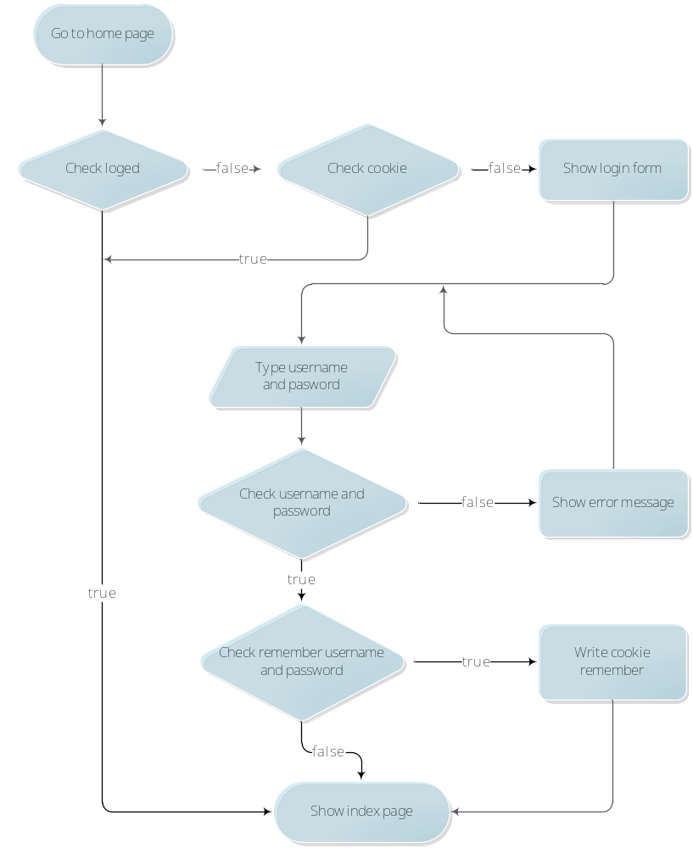

- Register
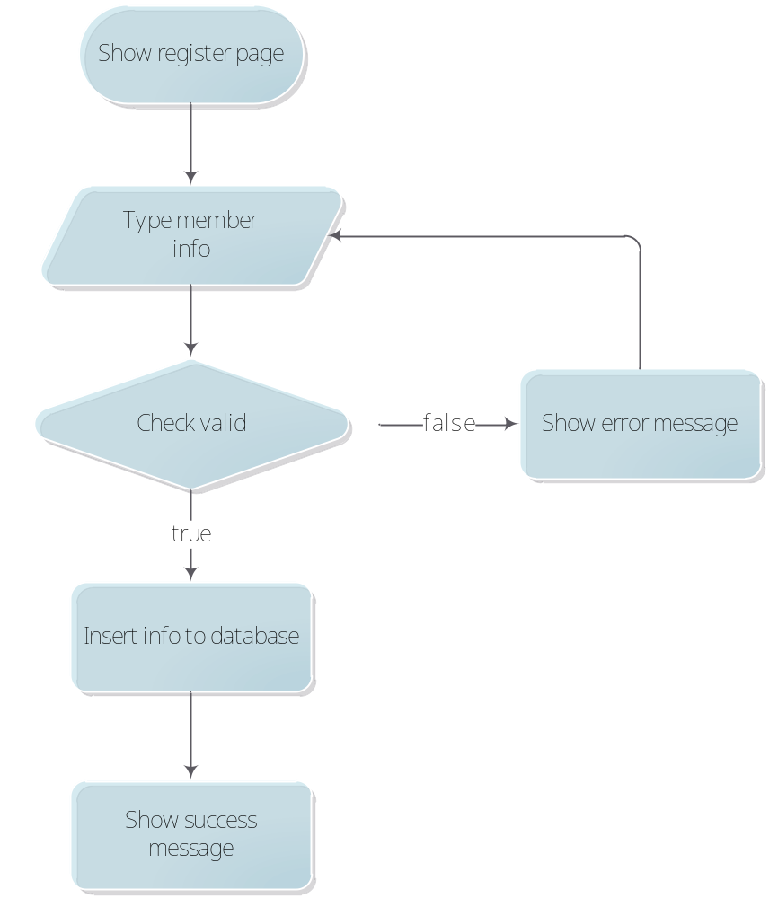

- Login(admin)

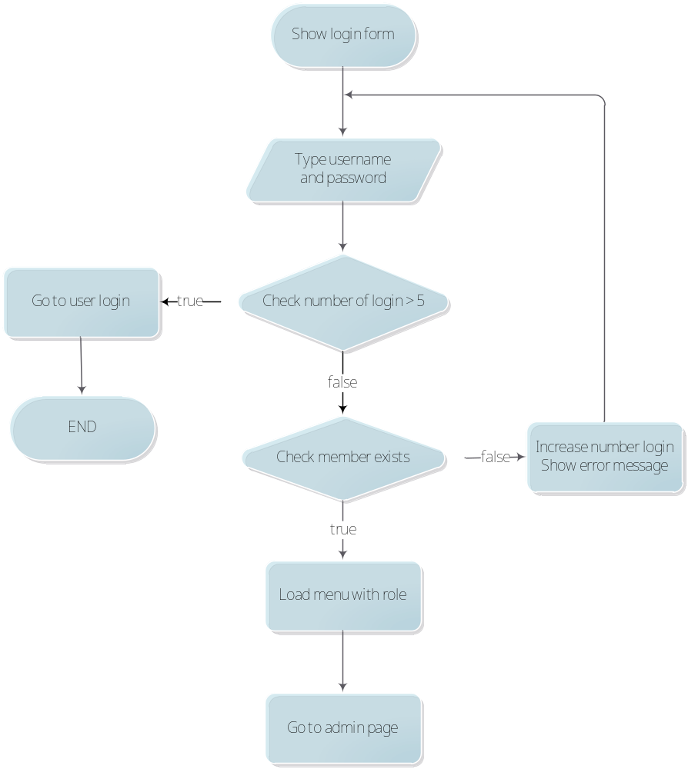

- Logout

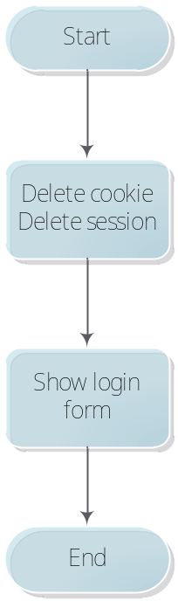

- Use Case and Diagram.
- Administrator
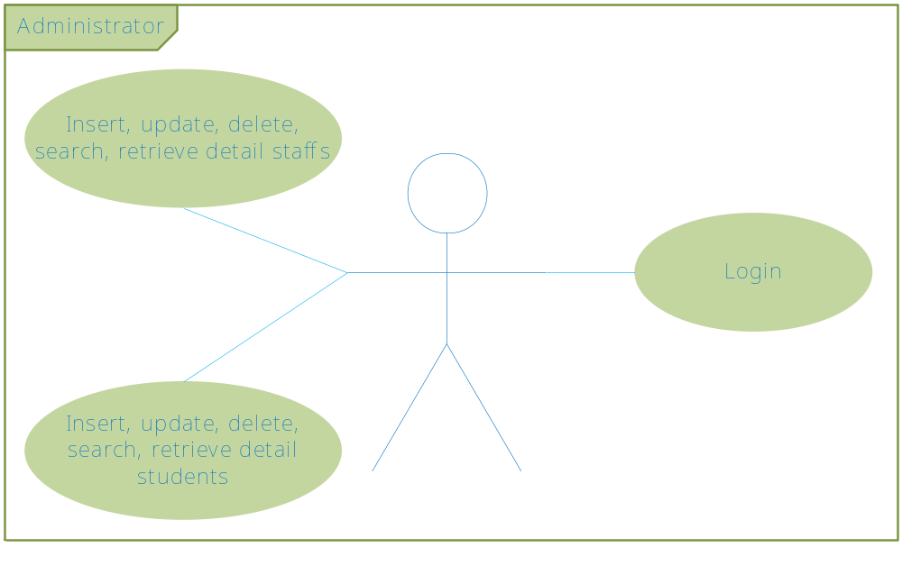

- Students

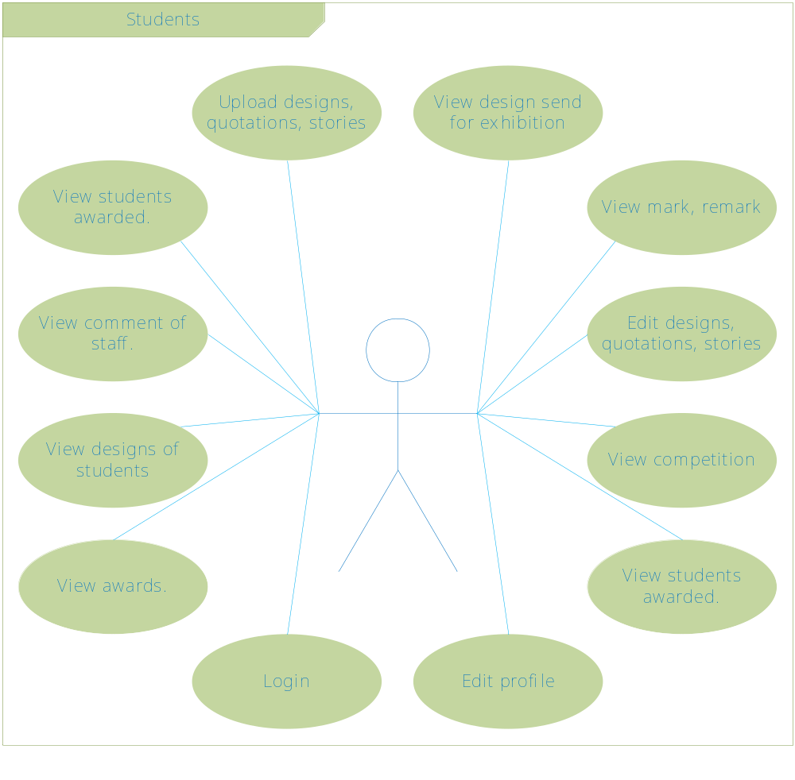

- Staffs

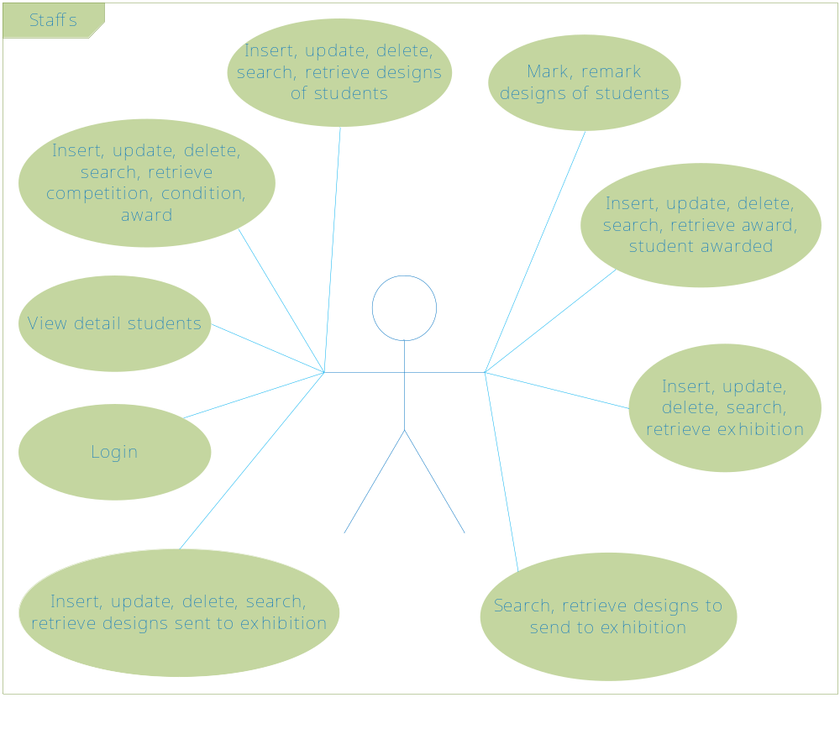

- Managers

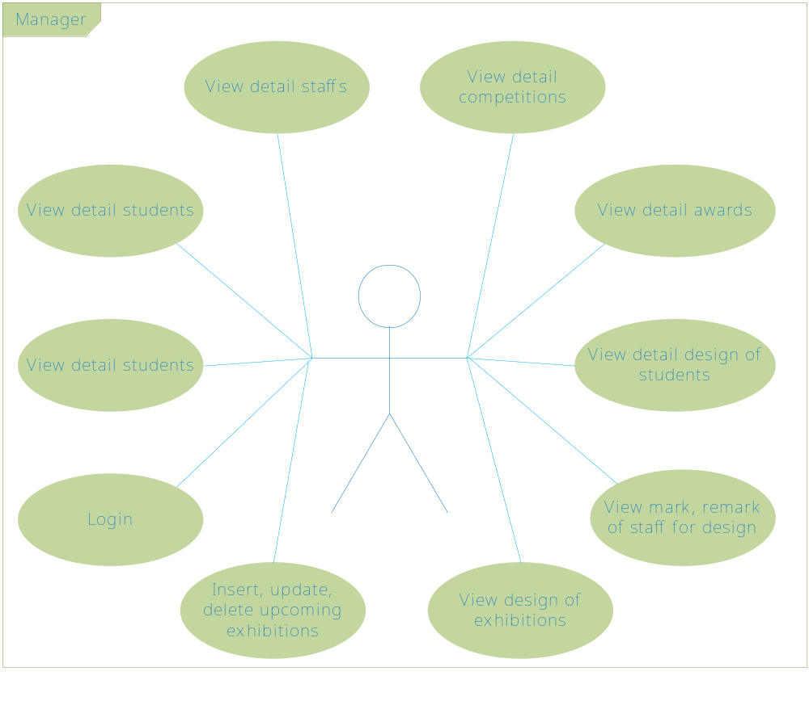

- Functional of Site
- Frontend
- Home page
- List of the upcoming competitions.
- List of the ongoing competitions.
- List of the students and detail students who are awarded for the previous competition.
- Detail competition
- Detail competition(start date, and date,…).
- Condition of competition.
- Awards of competition.
- List of designs
- List of design of the ongoing competitions.
- List of design of the previous competitions.
- Detail of design
- Detail of design(painting, stories, quotations, author, date post, mark, remark,…)
- List of design of the same competition.
- Upload, edit, delete, search and retrieve the designs page
- List of designs of student has functions as edit, delete, search and retrieve.
- Profile page
- Student information.
- Designs of student.
- Backend
- Manage students page
- List of student with delete, edit functions.
- Edit student page
- Manage staff page
- List of staff with delete, edit functions.
- Edit staff
- Manage competittion page
- List of competitions page with delete, edit functions.
- Edit competition page
- Add competition page
- Manage design page
- Manage awards page
- Edit award page
- Manage exhibitions
- Edit exhibition page
- Manage design of exhibition

- Interface Design Document.

SITE |  |  | Width : 960px ;  Background :#ffffff,#000000 ;
ALL |  |  | Font-size:10px;  font-family:"Lucida Grande", Lucida, "Trebuchet MS", sans-serif;  Text-decoration:none ;
BUTTON |  |  | Normal:  background:# DB1918;  color:#ffffff;
H  E  A  D  E  R | Navigation |  | Normal:  background:#000000;  color:#a7a7a7;  font-size:150%;  text-transform:uppercase;  Hover:  color:#DB1918;
H  E  A  D  E  R | Logo
H  E  A  D  E  R | Animation |  | background:#fff;
C  O  N  T  E  N  T | L  E  F  T | List of menu | Normal:  font-family: 'PT Sans Narrow', sans-serif;  font-size:80%;  color:#858585;  text-transform:uppercase;  Hover:  color:#db1918;
C  O  N  T  E  N  T | L  E  F  T | Login form | color:#747474;  font-size:120%
C  O  N  T  E  N  T | R  I  G  H  T | Main Content | Title:  background:#db1918;  font-size:180%;  color:#fff;  text-transform:uppercase;  Detail Article:  color:#242424;  font-size:120%;  Date Post:  color:#969696;  font-size:120%;  Date Competition:  font-size:120%;  color:#db1918;  Link More:  font-size:120%;  color:#00AEEF;
F  O  O  T  E  R | Infomation |  | font-size:120%;  color:#808080;  text-align:justify;  a:  color:#00AEEF;
F  O  O  T  E  R | Copyright |  | color:#474747;  text-transform:uppercase;  font-size:110%;

- Database Design
- Entity and Relationship

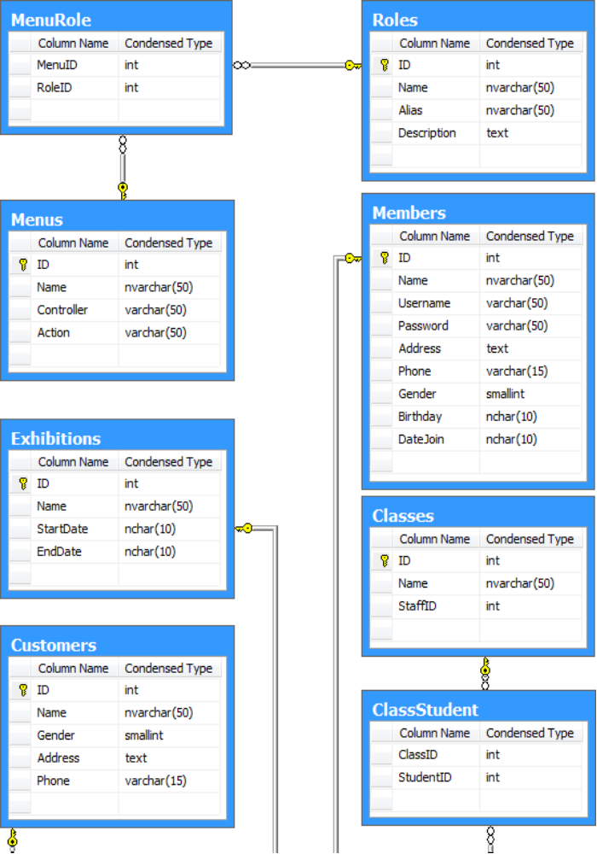

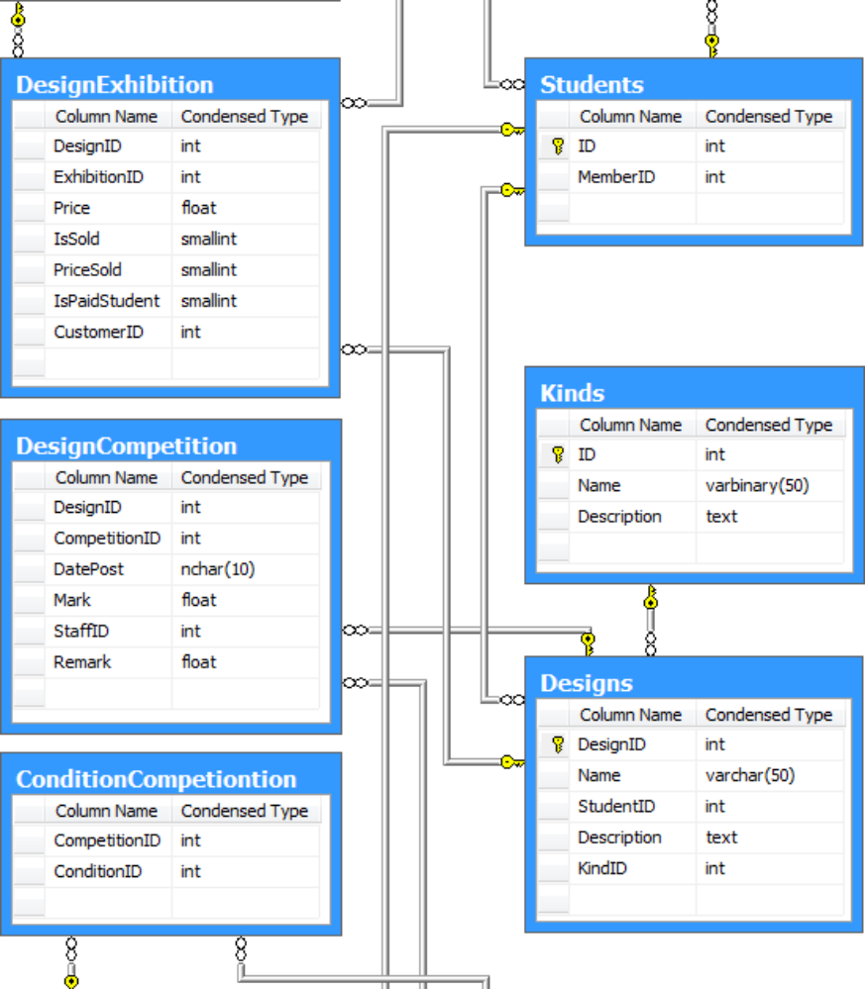

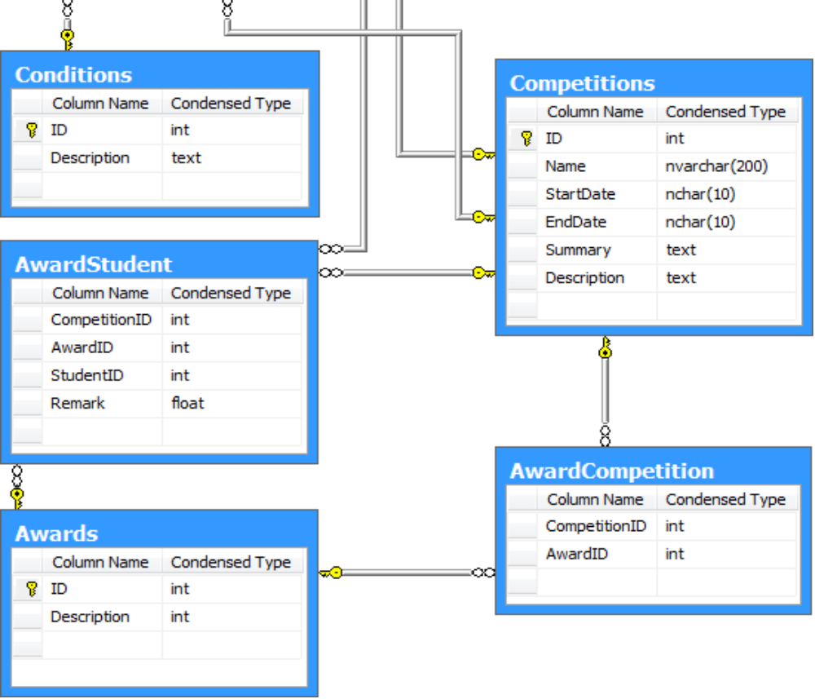

- Description
      - The site has competitions(Competitions), each competition has ID, competition name, start date of the competition, summary and description of the competition. Competitions has conditions(Conditions, ConditionsOfCompetition) and awards(Award, AwardOfCompetition).
      - Each competition has designs(Designs, DesignCompetition) of students(Students). A design has ID, design name, design kind(Kinds), design author(Students).
      - Institute of Fine Art has classes(Classes), students(Students, ClassStudent) and teacher(Staffs).
      - The site has exhibitions(Exhibitions), each exhibition has designs (DesignExhibition) and has customers(Customers).
      - The site has members(Members) with roles(Roles) and menus for role(MenuRole)

